Critical Thinking Diagram Analysis Name ____________________________
Period _____ Date _________________

Normal karyotype – a picture of an individual’s chromosomes.
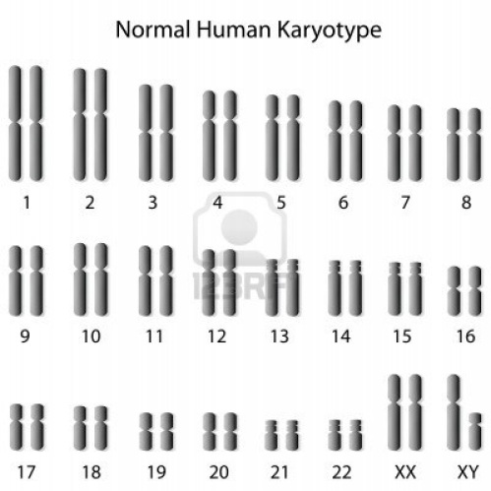
As this karyotype illustrates, an individual has two copies of each chromosome (one from mom and one from dad) in every cell – and thus two alleles for each gene. There are 23 sets of homologous pairs of chromosomes, for a total of 46 chromosomes. Notice that the two homologous chromosomes match up, except for the last pair: these are the sex chromosomes of a male (XY). A female’s sex chromosomes do match (XX). Both are illustrated in the chart to the left; in a real karyotype, only one set of sex chromosomes would be found.

1. Non-disjunction – an error when chromosomes don’t split properly in meiosis.

Human body cells normally have 46 chromosomes, made up of 23 homologous pairs. Gametes (eggs and sperm) have only 23 chromosomes. When gametes are produced during meiosis, the homologous chromosomes split so each gamete gets one chromosome from each of the 23 pairs. When an egg and sperm fuse during fertilization, the resulting zygote will again have a full 46 chromosomes (23 pairs).

But sometimes homologous pairs of chromosomes don’t separate properly during meiosis resulting in some gametes with an extra chromosome or one too few. If these gametes are involved in fertilization, the zygote produced will either have 22 pairs of chromosomes and an unmatched chromosome (a condition called monosomy) or the zygote will have 22 pairs of chromosomes and a trio of chromosomes (a condition called trisomy). When either a monosomy or trisomy occurs, the affected baby, if it develops at all, will have a genetic disorder. The karyotypes of some of these disorders are illustrated below.
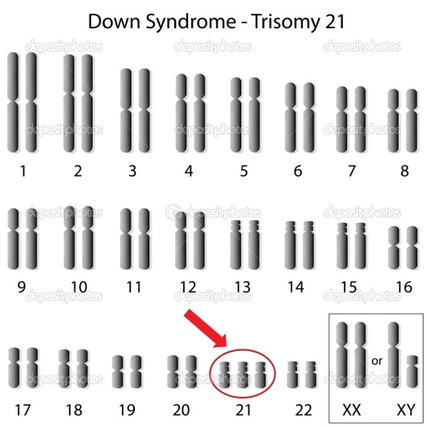
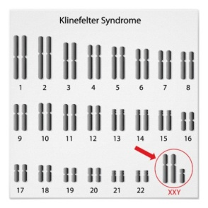
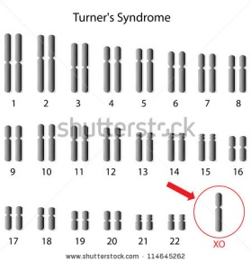

Complete the following.

- How does the karyotype of a person with Down syndrome differ from a person with a normal karyotype?

- What is the condition that that causes Down syndrome called?

- What condition causes Klinefelter syndrome?

- What condition causes Turner syndrome?

- Turner syndrome and Klinefelter syndrome both result from the same type of error during meiosis.
  - What is this error called?

  - Which pair of chromosomes is involved?

2. Chromosomal Mutation – when a section of a chromosome is affected.

Another type of disorder than can be diagnosed using karyotypes is a chromosomal mutation, when part of a chromosome is affected. Four types are possible.

- Inversion: a section of a chromosome detaches, flips, and reconnects backwards
- Deletion: a section of a chromosome is missing
- Duplication: a section of a chromosome is repeated
- Translocation: a section of a chromosome detaches and attaches to an inappropriate chromosome.

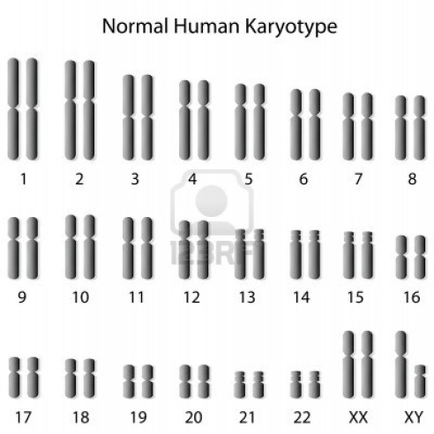
Cri-du-chat Karyotype

6. Use the karyotypes above to describe what is the cause of cri-du-chat syndrome?

3. Gene Mutation – when a single base mistake occurs.

Even a single base mistake in a gene’s DNA can cause disorders. Several types are possible.

- Deletion: a base is missing, affecting all the codons (sets of three bases that code for amino acids) that follow.
- Addition: a base is inserted, affecting all the codons that follow.
- Substitution or Point: one base is replaced by another, affecting only one codon.

Some Human Genetic Disorders

Disorder Type Cause Symptoms
Cystic fibrosis | Gene mutation | Recessive allele | Congestion in lungs, blockage of digestive track, pneumonia
Down syndrome | Non-disjunction | Trisomy of chromosome 21 | Developmentally disabled, diamond-shaped eyes, enlarged tongue
Klinefelter syndrome | Non-disjunction | Extra X chromosome | In males: underdeveloped testes, sterility, feminine body shape.  In females: sterility, developmentally disabled.
Tay-Sachs disease | Gene mutation | Recessive allele | Lipid accumulation in brain, seizures, blindness
Color blindness | Gene mutation | Sex linked (on X chromosome) recessive allele | Inability to distinguish between certain colors
Huntington’s disease | Gene mutation | Dominant allele | Deterioration of nervous system
Turner syndrome | Non-disjunction | Single X chromosome | Failure to develop sexually, sterility
Cri-du-chat syndrome | Chromosomal mutation | Deletion of a section of chromosome 5 | Extremely small head, distinctive cry, rarely survive more than 1 or 2 years.

Use the table above to answer the remaining questions.

- What is the cause of Tay-Sachs disease?

- What are the symptoms of Klinefelter syndrome in a man?

- What disorder is caused by trisomy of the 21st chromosome?

- What disorders are caused by recessive alleles?

- What disorders are caused by problems with the sex chromosomes (X or Y)?

