Lab: Cricket Ethograms and Behavioral Study Name ______________________________
Period _____ Date ____________________
Ethograms

The study of animal behavior starts with a description of the behaviors an animal exhibits. Before we can study how behavior develops, or what causes it, or how it affects an animal’s ability to survive and reproduce, we must know what the behavior is. We need a thorough description of the postures, movements, sounds, etc. that constitute the behavior, as well as a catalog of the situations in which it occurs, as well as the responses it elicits from other animals. Describing behavior, however, can be difficult. Animal behaviorists have developed ways to make their job (and ours) easier. On such way is the use of “ethograms.” An ethogram is an inventory of the behaviors of a species, with the behaviors thoroughly described and organized into categories. An ethogram places the animal’s behavioral repertoire into an organized structure, which enables animal behaviorists to discover how each behavior helps the animal to survive, to mate, and to reproduce. Ethograms also allow animal behaviorists to speculate about the evolution of behavior because similar behaviors can be compared among species in an evolutionary lineage.

Ways to Describe Behavior

There is no one right way to describe behavior. Two different ways to describe behavior: based on structure and based on consequences.

- “Structure description” characterizes the appearance or physical form of the behavior. In other words, the behavior is described in terms of the subject’s posture, movements, and sounds. Think, for example, about how you might describe a handshake in terms of postures, movements, and sounds of two interacting people.

- Consequences are the presumed effects of the subject’s behavior on itself, on its environment, or on other organisms. In “consequence description,” the behavior is described with respect to its presumed consequences without paying particular attention to the subject’s posture, movements, and sounds. The handshake, which could be described above as postures and movements, could also be described as a “greeting ceremony” in a consequence description.

Categories such as “obtain food” or “escape predator” are description in terms of their consequences. For example, “turn light on” is a consequence description, while “push switch down using index finger” is a description in terms of structure. Consequence description is the more economical of the two methods because it does not require the observer to make subtle discriminations between very complex movements. Subtle discriminations are important, but when first learning how to do ethograms, the structure description may be confusing. On the other hand, without structure descriptions, different workers may end up studying structurally different behaviors with similar consequences. For example, handshakes and “high fives” are both greetings involving the hands, but they occur in different contexts and are often used by different individuals.

- A third type of description is “relational” and concerns the organism’s spatial relations to other organisms or something in the environment. The focus is on where the organism is or with what it is, rather than what it is doing.

Categorizing behavior requires very close observation so accurate ethograms of the species under study can be constructed. This becomes more difficult when the organisms you are studying are members of an unfamiliar species. In order to familiarize you with the construction of ethograms we will start with a common organism, the house cricket. We will use a checklist for our first observation. This will help us familiarize ourselves with observing behavior. We will then use the “behavior scan” method to construct ethograms of the crayfish alone and together.

Background on Dominance Behaviors

Animals must compete for critical resources such as food or mates, but the form of this competition can differ from one kind of animal to another. In some animals the competition is in the form of a “test of efficiency” or “scramble competition” in which there are no direct confrontations. Instead, the “winner” of the competition is the animal that acquires the critical resource the fastest, or in the greatest amount. An analogy for such competition is the “cola war” in which competing soft drink companies spend money to advertise their products, and the most effective advertisers gain the greatest market share.

In other cases, individuals or sometimes groups of individuals physically defend specific areas in an attempt to sequester sufficient resources. An analogy of such “resource defense competition” or “interference competition” is a street gang defending its “turf” against invasions by other gangs. The circumstances under which territory defense is advantageous to defending individuals have been studied by many animal behaviorists. In general, the resources being defended must be in short supply. There would be no advantage to spending time and energy defending something that was so common everyone could get enough. And it would be too difficult to sequester resources that moved from place to place, or whose distribution was unpredictable in time (here today, gone tomorrow). Territory defense, then, is a sort of economic practice; individuals and species attempt to defend specific areas and maintain exclusive access to them only when the benefits of doing so outweigh any costs.

Many different kinds of animals defend territories. Sometimes a single individual defends an area against all others of the same sex and species. In other cases one individual defends an area against individuals of other species. In still others, several individuals join together to defend the territory against others of the same or other species.

A territory may be defined as an area that is used more or less exclusively by an individual or a group as a result of overt defense (e.g. fighting) and advertisement (e.g. singing, posturing), which prevents others from entering. Territories have one common theme: they provide a valuable resource, such as nesting sites, food, or shelter, to the territorial resident that enables that resident (the territory owner) to survive and reproduce. We will examine territory defense by crayfish in the second part of this lab.

Cricket Background
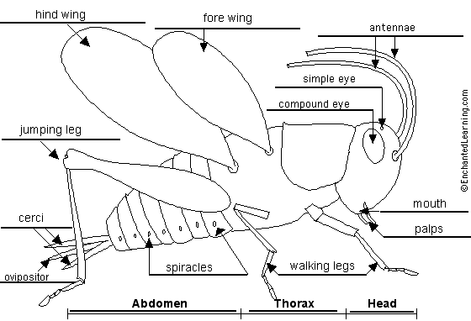
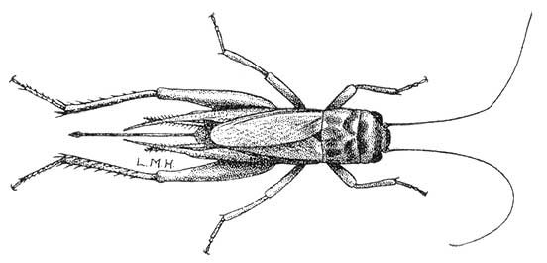 | 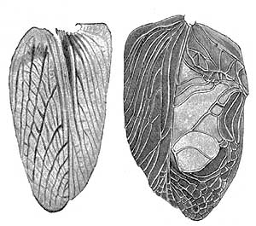
Acheta domesticus, adult female,  body length 15mm, ovipositor 12 mm | Female (left) and male wings of  Gryllus field crickets
House crickets are often associated with the new year and good luck. Although some (including the Audubon field guide) say that crickets are a nuisance because of their continuous chirping, others value them for that very characteristic. Indeed, unlike most other insects, cricket songs are characterized by almost pure tones of constant frequency.
In China and Japan, crickets have been brought indoors to delight inhabitants for almost 1000 years! Valued for their song, crickets were kept in small cages of bamboo or other materials. Crickets were also valued for sport, with cricket fighting coming into vogue during the Sung Dynasty (960-1279 A.D.). Books detailing the collection, care and feeding of crickets were written, as well as techniques for conducting a proper cricket fight. Fighting may be highly demanding in terms of energy costs for crickets, whereas acoustic signaling is likely the most efficient antagonistic response.
Generally, only male crickets stridulate or sing. Additionally, the relative amount of sound production varies within a population, some males being better songsters than others. And in a few species, the ability to produce sound has been lost altogether. A cricket song is distinct for each species, and indeed, the discriminating field biologist can tell how many species of crickets there are in an area simply by listening, somewhat like a good birder!
.
Cricket songs are produced with the forewings, or tegmina. The vein Cu2 of the tegmina is sclerotized in a series of sharp teeth to form a file. Further, a sharp-edged sclerotized ridge on the outer edge of the wing forms a plectrum, or scraper. By moving the scraper across the other wing's file, a vibration is set up which resonates on an area of the wing known as the harp.
Some other things that might be of interest:
- Call frequency is a reliable indicator of male size. That means a female cricket can tell how big a male is just by listening to the pitch of the song.
- Male crickets produce spermatophores to transfer sperm to the female
- Most crickets mate with the female on top
The Cricket Lab

Categorizing behavior requires very close observation so accurate ethograms of the species under study can be constructed. This becomes more difficult when the organisms you are studying are members of an unfamiliar species. In order to familiarize you with the construction of ethograms we will start with a common organism, the house cricket (Achetus domesticus). We will use a checklist for our first observation. This will help us familiarize ourselves with observing behavior. We will then use the “behavior scan” method to construct ethograms of the cricket alone and together.

Here are some basic behaviors you might see and record:

- Antennae cleaning
- Leg cleaning
- Eating.
- “Singing”
- Chasing
- Following
- Fighting
- Biting
- Drinking water
- Mating
- Wing flaring
- Pushing
- Guarding
- Ovipositor insertion

Methods

Crickets should be obtained about 5 days before the lab, separated by sex and a single male placed in each observation terrarium, so that he may establish his territory. This male should be identified with a mark (correction fluid or Sharpie) on his thorax. Feed crickets dog food, apple, oats, or commercial cricket food. Supply water on a sponge or damp paper towel. Too much humidity can kill crickets.

Day 1

First observation (single male cricket)

Groups make observations of single male in terrarium for 20 minutes, using the scan method to construct an ethogram. Make a “scan” at 30 second intervals and record the behavior. Check the category of behavior the cricket is making at each 30 second interval on the data sheet below. The results of the ethogram will be used to construct a “time budget” of behavior (what percentage of time is spent in each category) or to identify the sequence in which behaviors occur.

DATA

Species: Achetus domesticus, adult male
Date : ________________________
Time: ________________________
Observers: ________________________
________________________
________________________

Time | Category of Behavior (eating, cleaning antennae, etc.)
0:00
0:30
1:00
1:30
2:00
2:30
3:00
3:30
4:00
4:30
5:00
5:30
6:00
6:30
7:00
7:30
8:00
8:30
9:00
9:30
10:00
10:30
11:00
11:30
12:00
12:30
13:00
13:30
14:00
14:30
15:00
15:30
16:00
16:30
17:00
17:30
18:00
18:30
19:00
19:30

Data Analysis: 1 male alone. Make a bar graph of your results on the last page of this packet.

Behavior | No of checks | Percent
Behavior | No of checks | Percent

Second Observation (two crickets)

Groups choose whether to introduce a male or female cricket into the terrarium.

Gender of cricket added :________________ Hypothesis of what will occur: ______________________________________
____________________________________________________________________________________________________

Introduce the new cricket to the terrarium. Allow the new cricket 5 minutes to calm down before making observations. Use the scan method to make an ethogram of the behaviors of the crickets for 20 minutes. Half of the group should monitor the 1st male cricket’s behavior and half of the group should monitor the newly introduced cricket’s behavior.

DATA

Species: Achetus domesticus, ______________
Date : ________________________
Time: ________________________
Observers: ________________________
________________________
________________________

Time | Category of Behavior (eating, cleaning antennae, etc.)
0:00
0:30
1:00
1:30
2:00
2:30
3:00
3:30
4:00
4:30
5:00
5:30
6:00
6:30
7:00
7:30
8:00
8:30
9:00
9:30
10:00
10:30
11:00
11:30
12:00
12:30
13:00
13:30
14:00
14:30
15:00
15:30
16:00
16:30
17:00
17:30
18:00
18:30
19:00
19:30
Data Analysis: Original male with a second cricket. Gender of 2nd cricket ______.

Behavior | No of checks | Percent

Behavior | No of checks | Percent

Make a bar graph of your results on the last page of this packet.

Was your hypothesis correct? Explain:

How did the behaviors of the cricket you observed compare to the behaviors observed of the single male?

DAY 2

Third Observation (three crickets)
For the first experiment of the day, you will add a cricket of the opposite gender of the one that was added on Day 1. Allow the new cricket 5 minutes to calm down before making observations. Make an ethogram of the behavior of one of the crickets (each observer should observe a different cricket).

Gender of cricket added :________________ Hypothesis of what will occur: ______________________________________
____________________________________________________________________________________________________

DATA

Species: Achetus domesticus, ______________
Date : ________________________
Time: ________________________
Observers: ________________________
________________________
________________________

Time | Category of Behavior (eating, cleaning antennae, etc.)
0:00
0:30
1:00
1:30
2:00
2:30
3:00
3:30
4:00
4:30
5:00
5:30
6:00
6:30
7:00
7:30
8:00
8:30
9:00
9:30
10:00
10:30
11:00
11:30
12:00
12:30
13:00
13:30
14:00
14:30
15:00
15:30
16:00
16:30
17:00
17:30
18:00
18:30
19:00
19:30
Data Analysis: Original male. Second cricket gender __________. Third cricket gender _________.

Behavior | No of checks | Percent

Behavior | No of checks | Percent

Make a bar graph of your results on the last page of this packet.

Was your hypothesis correct? Explain:

How did the behaviors of the crickets change when a third cricket was introduced?

Fourth Observation (Independent)

For the final experiment your group should design its own experiment regarding cricket behavior. Some possibilities include:

- How do environmental factors (light, day length, heat, etc.,) affect cricket behavior?
- How do male crickets identify females?
- Are female crickets territorial?
- How would a territorial male react if placed in a new territory?
- Is chirping different in male-male interactions as opposed to male-female interactions?

Explain your experimental design:

Hypothesis:
Collect and analyze data in an appropriate manner. An additional ethogram data sheet is provided should you choose to use it.

DATA (Attach a separate sheet, or use the back of the packet, if you don’t use this data sheet)

Species: Achetus domesticus, ______________
Date : ________________________
Time: ________________________
Observers: ________________________
________________________
________________________

Time | Category of Behavior (eating, cleaning antennae, etc.)
0:00
0:30
1:00
1:30
2:00
2:30
3:00
3:30
4:00
4:30
5:00
5:30
6:00
6:30
7:00
7:30
8:00
8:30
9:00
9:30
10:00
10:30
11:00
11:30
12:00
12:30
13:00
13:30
14:00
14:30
15:00
15:30
16:00
16:30
17:00
17:30
18:00
18:30
19:00
19:30

Data Analysis:

Behavior | No of checks | Percent
Behavior | No of checks | Percent

Was your hypothesis correct? Explain:

Conclusions:

Bar Graphs

Experiment 1: Single male Experiment 2:

Experiment 3:

Experiment 4:

Conclusion

At least one paragraph on each of the following ideas:

- a discussion of some of the problems you encountered and possible solutions

- use your data to draw conclusions about the duration (how long), frequency (how often), and sequences (in what order) of the categories of behavior you identified.

- Use your data from the experiments to draw conclusions about cricket dominance and its relationship to the sex of individuals

Credit: This lab was hugely plagiarized from Paul Kelly, of Park Hill High School (Kansas City, MO) and Mike McNabb of Ballard High School (Louisville, KY)

